|  |
| --- |
| EPAM Systems, RD Dep., RD Dep.  MTN.*NIX.07 Oracle DB. Introduction to DWH |
| MTN.*NIX.07 Labs - Basic Parallel Execution |

|  |  |  |  |  |  |
| --- | --- | --- | --- | --- | --- |
| REVISION HISTORY | | | | | |
| Ver. | Description of Change | Author | Date | Approved | |
| Name | Effective Date |
| 1.0 | Initial status of document | [**Kiryl Bucha**](mailto:Kiryl_bucha@epam.com) | 16-JAN-2012 |  |  |
|  |  |  |  |  |  |

*Contents*

1. Prerequisites Task Information 3

1.1. Passwords Index 3

1.2. Folder Paths Index 3

2. Oracle Architecture - Parallel execution 3

2.1. Task 01: CREATE Example of Select Parallel execution 3

2.2. Task 02: CREATE Example of Parallel DML 3

2.3. Task 03: CREATE Example of Parallel DDL 4

3. Oracle Architecture - Parallel execution 4

# Prerequisites Task Information

## Passwords Index

|  |  |  |
| --- | --- | --- |
| Password Group | Login Name | Password |
| Operation System | root | “rootadmin” |
|  | oracle | “oracleadmin” |
|  |  |  |
| Oracle System | sys | “sysadmin” |
|  | system | “sysadmin” |
|  |  |  |
| Oracle Users | All DB users | “%PWD%” |
|  |  |  |
|  |  |  |

## Folder Paths Index

|  |  |  |
| --- | --- | --- |
| Path Group | Path Description | Path |
| Operation System | Oracle RDBMS – BIN | /oracle/app/oracle |
|  | Oracle Inventory | /oracle/app/oraInventory |
|  | Oracle Database Storage | /oracle/oradata |
|  | Oracle Install Directory | /oracle/install |
| Oracle | ORACLE_BASE | /oracle/app/oracle |
|  | ORACLE_HOME | $ORACLE_BASE/product/11.2 |
|  |  |  |
| FTP | ftp Incoming Folder | **/ftp/incoming** |
|  |  |  |
|  |  |  |

# Oracle Architecture - Parallel execution

## Task 01: CREATE Example of Select Parallel execution

**The Main Task** is to creating example of Select Parallel execution.

**Task Results:**

Create document that will store all screenshot about Select Parallel execution

* Scipts
* Execution Plan

Select from table without parallel (100 000 rows).

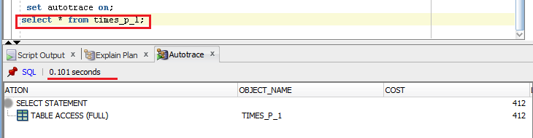

5000 rows 1.774 sec

With parallel

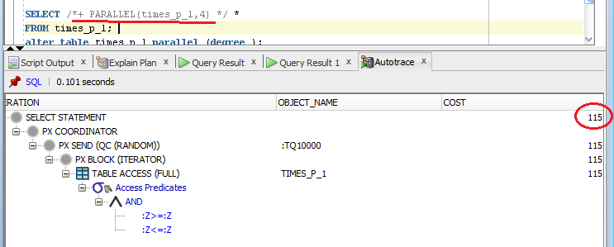

5000 rows 1.600 sec

* Summarize table – Compare time of the same operations

## Task 02: CREATE Example of Parallel DML

**The Main Task** is to creating example of Parallel DML

**Task Results:**

Create document that will store all screenshot about Parallel DML

* Scipts
* Execution Plan

Without parallel

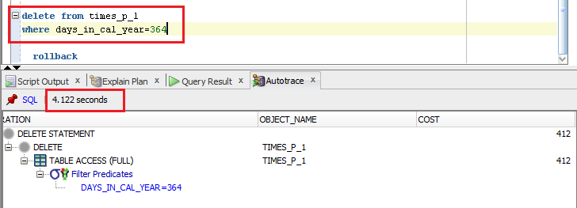

With parallel degree 4

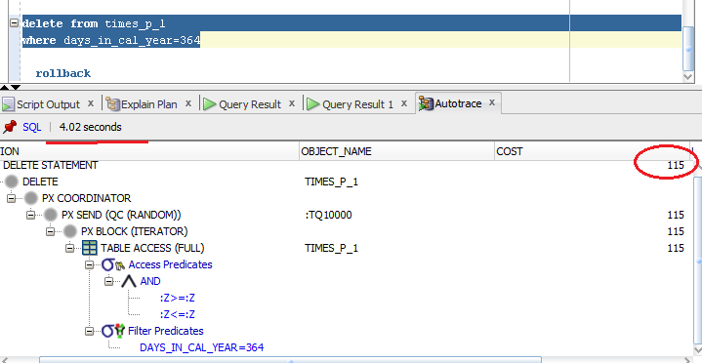

* Summarize table – Compare time of the same operations

## Task 03: CREATE Example of Parallel DDL

**The Main Task** is to creating example of Parallel DDL

**Task Results:**

Create document that will store all screenshot about Parallel DDL

* Scipts
* Execution Plan

Without parallel

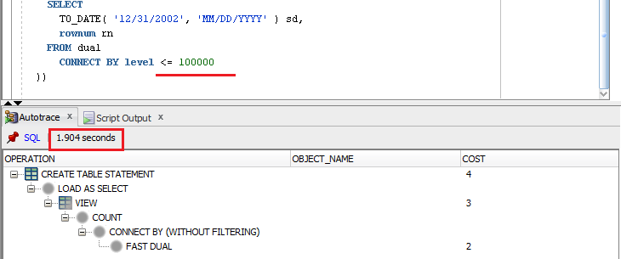

With parallel

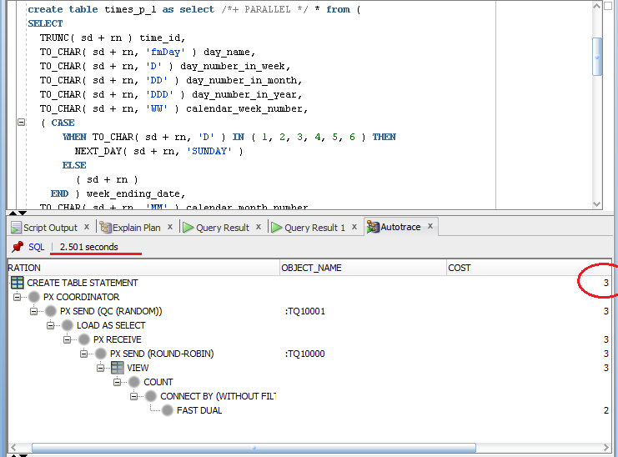

* Summarize table – Compare time of the same operations

# Business Task - Parallel execution

## Task 03: CREATE Strategy of Parallel execution

**The Main Task** is to creating Strategy of Parallel execution for yours Business Task according Solution Concept.

**Task Results:**

* Add chapter to Solution Concept describing Strategy of Parallel refreshing Fact Tables and Dimension Tables.

# Strategy of Parallel execution

In my data warehouse system, large tables FCT_Sales, SCD_DIM_PRODUCTS and SCD_DIM_CUSTOMERS need to be refreshed (updated) periodically with new or modified data from the production system. I can do this efficiently by using parallel DML combined with updatable join views. It also increase the speed of DDL.

The data that needs to be refreshed will be loaded into table before starting the refresh process. This table will contain either new rows or rows that have been updated since the last refresh of the data warehouse. After all changes will be done, the data will be pushed to public views.